Day 6 Project and Challenges:- Using functions, for loop, while loop and conditional statements.

Challenge 1:-

Reeborgs World Hurdle 1 Challenge - <https://reeborg.ca/reeborg.html?lang=en&mode=python&menu=worlds%2Fmenus%2Freeborg_intro_en.json&name=Hurdle%201&url=worlds%2Ftutorial_en%2Fhurdle1.json>

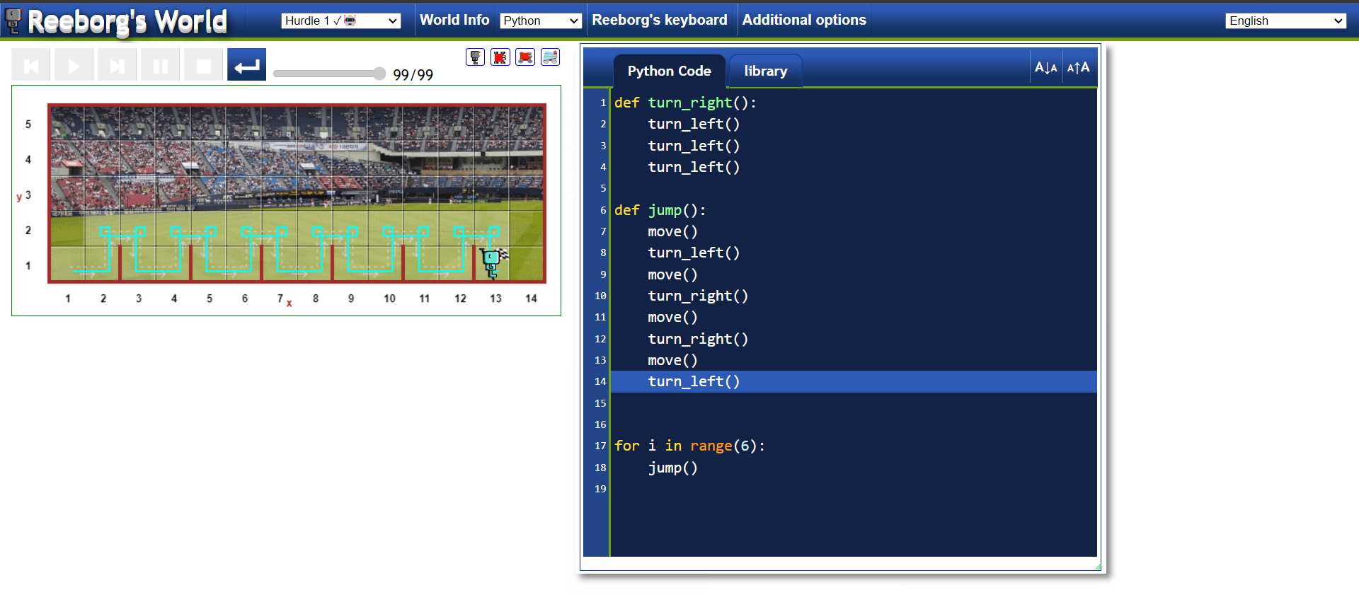

Challenge 2:-

Reeborgs World Hurdle 2 Challenge - <https://reeborg.ca/reeborg.html?lang=en&mode=python&menu=worlds%2Fmenus%2Freeborg_intro_en.json&name=Hurdle%202&url=worlds%2Ftutorial_en%2Fhurdle2.json>

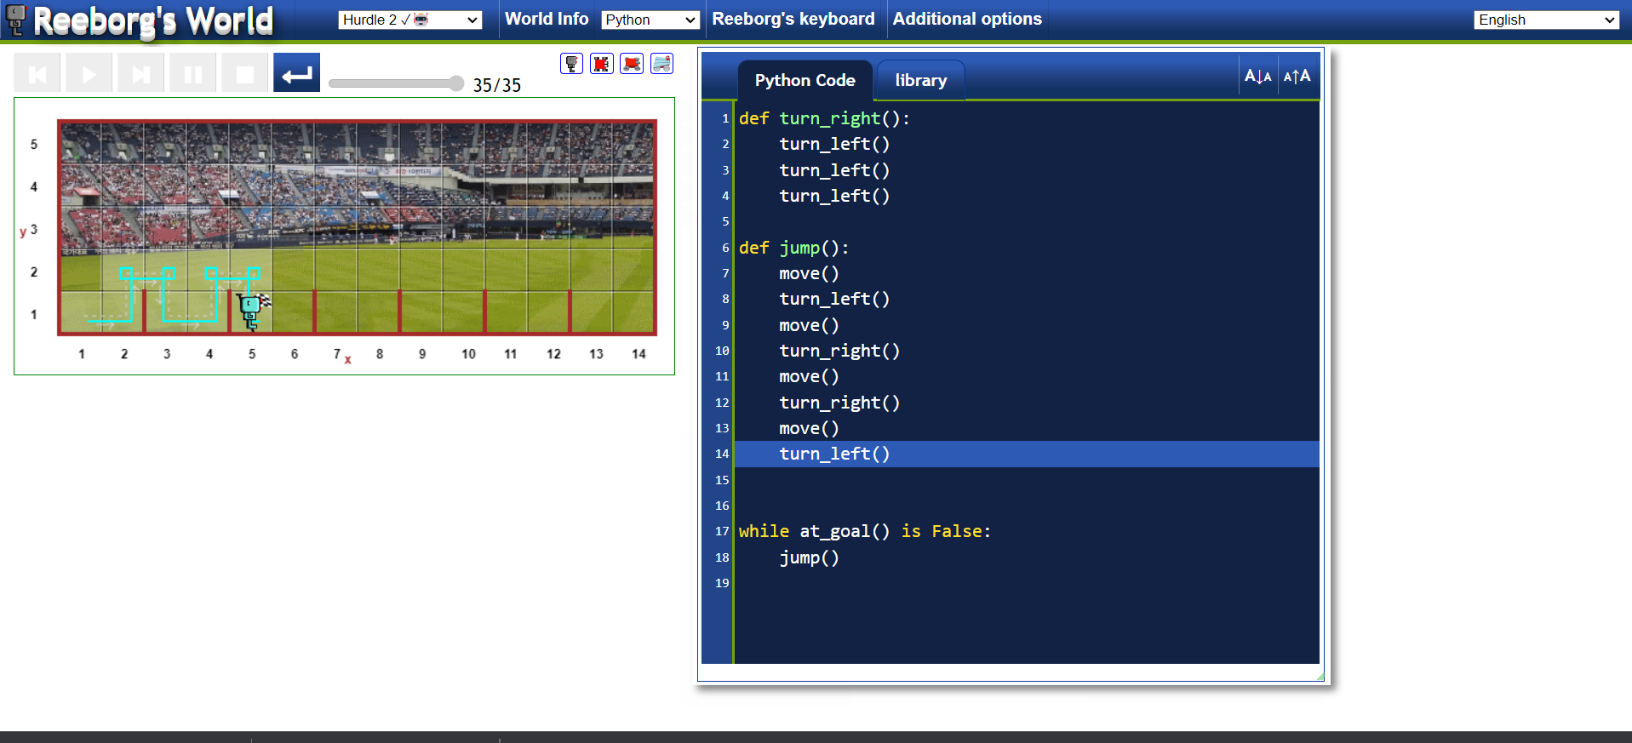

Challenge 3:-

Reeborgs World Hurdle 3 Challenge - <https://reeborg.ca/reeborg.html?lang=en&mode=python&menu=worlds%2Fmenus%2Freeborg_intro_en.json&name=Hurdle%203&url=worlds%2Ftutorial_en%2Fhurdle3.json>

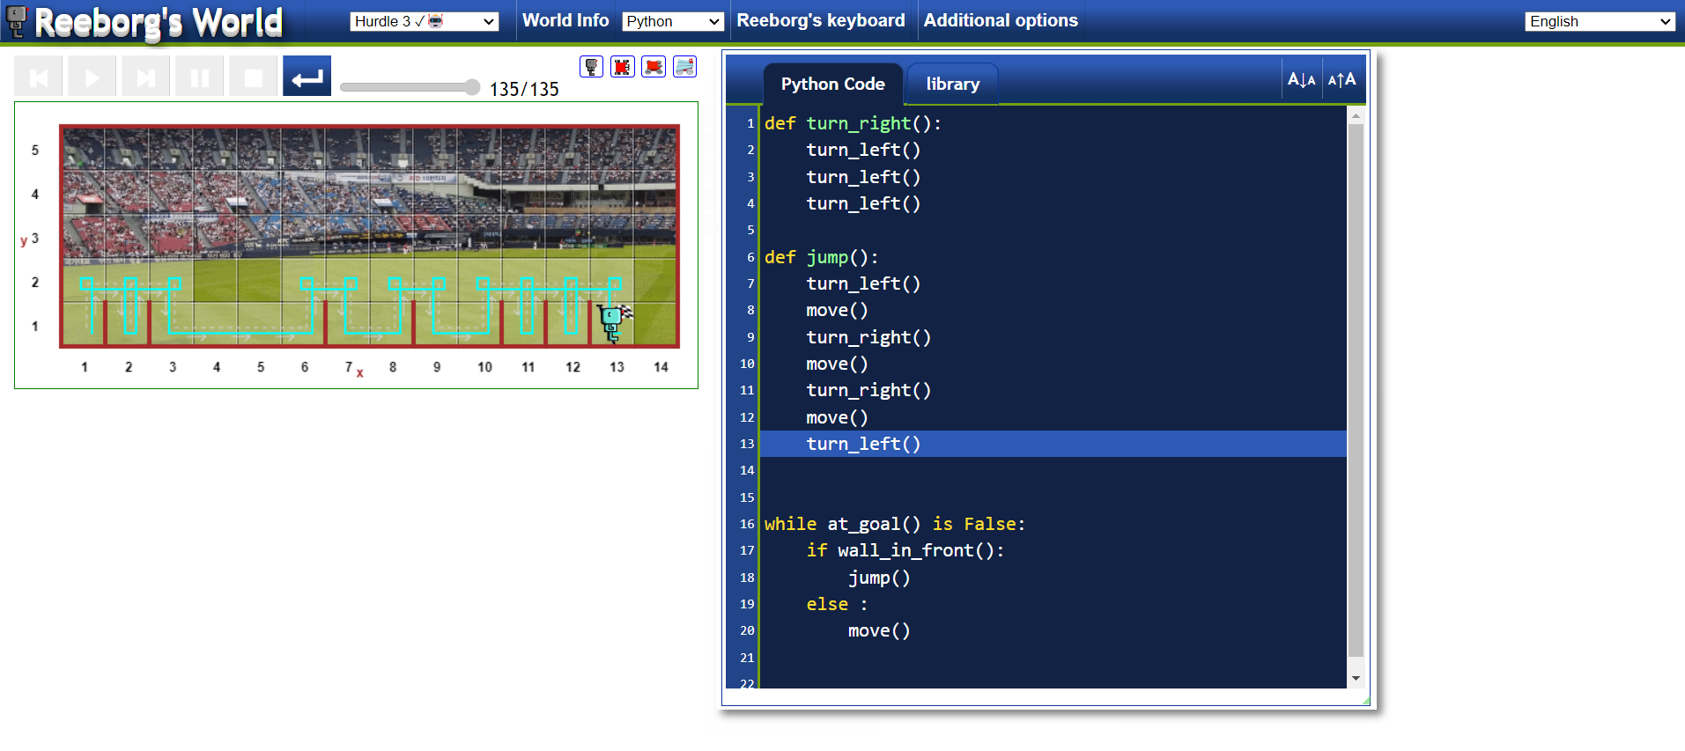

Challenge 4:-

Reeborgs World Hurdle 4 Challenge - <https://reeborg.ca/reeborg.html?lang=en&mode=python&menu=worlds%2Fmenus%2Freeborg_intro_en.json&name=Hurdle%204&url=worlds%2Ftutorial_en%2Fhurdle4.json>

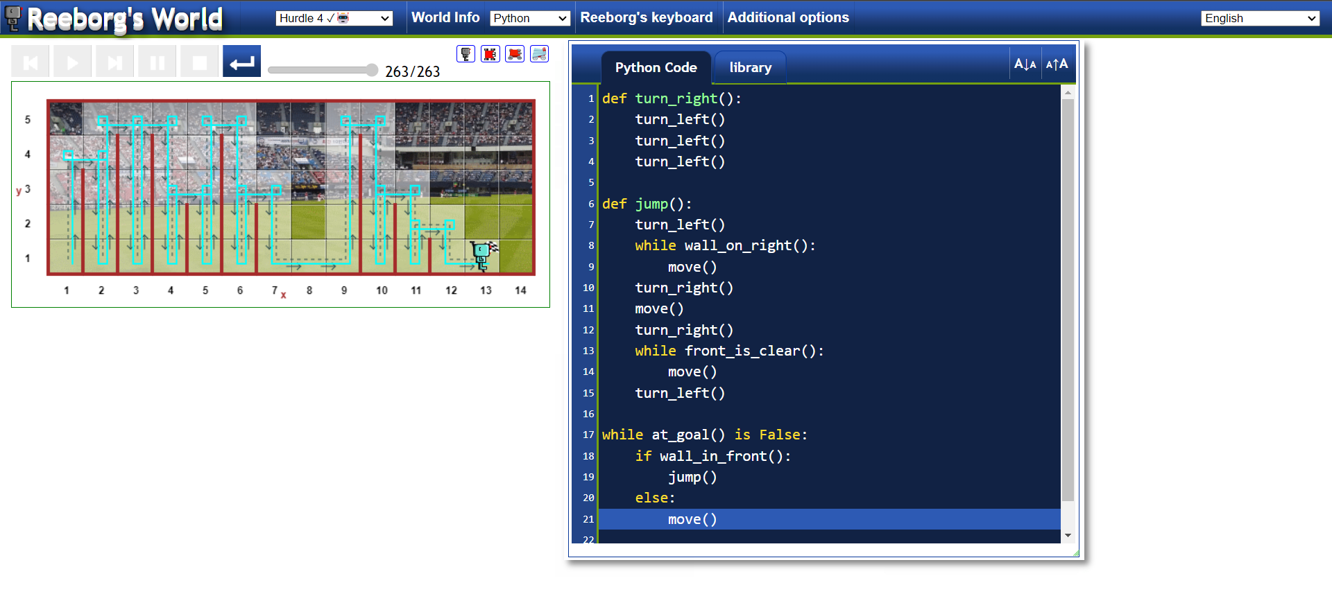

Project – Escaping the Maze

Reeborgs Maze Project - <https://reeborg.ca/reeborg.html?lang=en&mode=python&menu=worlds%2Fmenus%2Freeborg_intro_en.json&name=Maze&url=worlds%2Ftutorial_en%2Fmaze1.json>

